**Input and Output Problems (String and Numeric Variables)**

**Task 2:**

**Plan:**

1. As user “what is your first name?” and store input in variable.
2. As user “what is your surname?” and store input in variable.
3. Output variables value in a sentence.

**Pseudocode:**

firstName = input (“What is our first name? ”)

surname = input(“What is your surname? ”)

output (surname, firstName, “Your names have”, length of(surname), “and”, length of (firstName), “letters”, “Your initials are”, surname[0], firstName[0])

**Variables table:**

|  |  |  |
| --- | --- | --- |
| Variable name | Data type | comment |
| firstName | string | stores user input |
| surname | string | Stores user input |

**Screenshot evidence:**

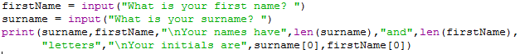

In the screenshot above is 2 variables are created that stores the user’s input, and a print statement to display the variables content.

**Sample run (Output):**

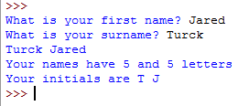

**Flow charts:**

print(firstName, surname)

firstName = input("What is your first name? ")

surname = input("What is your surname? “)

Start